**Project Planning Phase**

**Project Planning Template (Product Backlog, Sprint Planning, Stories, Story points)**

|  |  |
| --- | --- |
| Date | 27 JUNE 2025 |
| Team ID | LTVIP2025TMID47711 |
| Project Name | Project - HouseHunt |
| Maximum Marks | 4 Marks |

**Product Backlog, Sprint Schedule, and Estimation (2 Marks)**

| **Sprint** | **Functional Requirement (Epic)** | **User Story Number** | **User Story / Task** | **Story Points** | **Priority** | **Team Members** |
| --- | --- | --- | --- | --- | --- | --- |
| Sprint-1 | Search and Filters | USN-1 | As a user, I want to search for properties by location, price range, and property type (apartments, villas, etc.) so I can find listings that meet my needs. | 3 | High |  |
| Sprint-1 | User Accounts & Communication | USN-2 | **As a user, I want to create an account** through Gmail **with proper authentication and save my searches and favourite listings so I can easily access them later.** | 2 | High |  |
| Sprint-1 | User Accounts & Communication | USN-3 | As a user, I will receive confirmation email once I have registered for the application | 1 | High |  |
| Sprint-2 | Market Insights | USN-4 | **As a user, I want to see an indicator on listings of current and past price changes in the area.** | 2 | Low |  |
| Sprint-2 | Environmental data | USN-5 | As a user, I want to see an overlay on listings showing estimated noise levels and air quality. | 2 | Low |  |
| Sprint-1 | Detailed Listings | USN-6 | **As a user, I want to view detailed listings with high-quality photos and videos so I can get a good sense of the property.** | 2 | Medium |  |
| Sprint-1 | User Accounts & Communication | USN-7 | As a user, I want to contact sellers or landlords directly through the platform to inquire about properties. | 2 | High |  |
| Sprint-3 | Neighbourhood Insights | USN-8 | As a user, I want to have an idea about the surrounding neighbourhood, including schools, parks, and amenities. | 2 | High |  |
| Sprint-2 | Community Rating, Reviews and Feedback | USN-9 | As a user, I want to read reviews from other users about neighbourhoods and property management companies. | 4 | Medium |  |
| Sprint-2 | School district & commute overlays | USN-10 | As a user, I want to filter listings based on commute time to specific locations (work, school). | 2 | Low |  |
| Sprint-3 | Dashboard for sellers, agents and landlords | USN-11 | **As a seller/landlord, I want to host a live, interactive open house directly on the platform, upload images, be able to directly communicate with clients and schedule meetings.** | 4 | High |  |
| Sprint-3 | Notifications | USN-12 | As a user, I want to be notified when new listings matching my saved searches become available. | 1 | High |  |
| Sprint-3 | Security Considerations Enforcement | USN-13 | As a user, seller, dealer or landlord I want to deal with only legitimate and authorized individuals as well as property and want my own information to be secure. | 3 | High |  |

**Project Tracker, Velocity & Burndown Chart: (2 Marks)**

**Project Tracker:**

| **Sprint** | **Total Story Points** | **Duration** | **Sprint Start Date** | **Sprint End Date (Planned)** | **Story Points Completed (as on Planned End Date)** | **Sprint Release Date (Actual)** |
| --- | --- | --- | --- | --- | --- | --- |
| Sprint-1 | 10 | 5 Days | 28 June 2024 | 1 July 2024 | 10 | 1 July 2024 |
| Sprint-2 | 10 | 5 Days | 2 July 2024 | 6 July 2024 | 10 | 6 July 2024 |
| Sprint-3 | 10 | 5 Days | 7 July 2024 | 12 July 2024 | 10 | 12 July 2024 |

**Velocity:**

We have a 5-day sprint duration, and the velocity of the team is 10 (points per sprint). Calculating the team’s average velocity (AV) per iteration unit (story points per day)

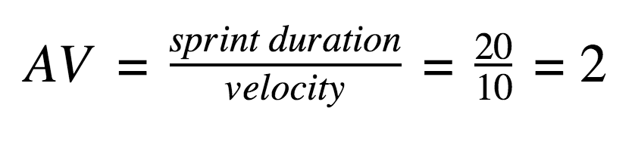

**Burndown Chart:**

A burndown chart is a graphical representation of work left to do versus time. It is often used in agile[software development](https://www.visual-paradigm.com/scrum/what-is-agile-software-development/) methodologies such as [Scrum](https://www.visual-paradigm.com/scrum/scrum-in-3-minutes/). However, burn down charts can be applied to any project containing measurable progress over time.



# JIRA PLANNING

